Annex DD. Learing rate in a Neural network

Optimizers within the GD family are usually challenged in that the learning rate must be defined a priori and they can get stuck in local minima or around saddle points if the error function is not convex (as it is for linear regression). Learning rate is the amount that the weights are updated during training (Trehan 2020).
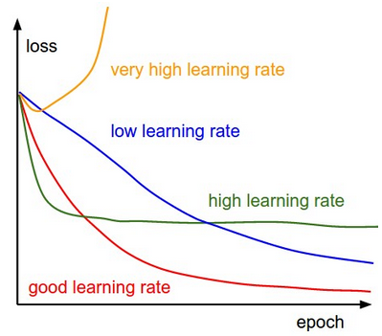
Fig. 1.3. Gradient descent with different learning rates (Fei-Fei, 2020)

The plot above tries to summarize the effect of value on the convergence of the gradient descent algorithm (Figure 1.3.):
- the yellow plot shows the divergence of the algorithm when the learning rate is high wherein the learning steps overshoot;
- the green plot shows the case where the learning rate is not as large as the previous case but is high enough that the steps keep oscillating at a point which is not the minima;
- the red plot would be the optimum curve for the cost drop as it drops steeply initially and then saturates very close to the optimum value;
- the blue plot is the lowest value and converges very slowly as the steps taken by the algorithm during update steps are very small.
Generally, the learning rate is selected by hyperparameter optimization. In selecting a learning rate, the trade-off between the rate of convergence and overshooting should be found.
If an inadequate number of neurons are used, the network will be unable to model complex data, and the resulting fit will be poor. If too many neurons are used, the training time may become excessively long, and the network may overfit the data. The result is that the model fits the training data extremely well, but it generalizes poorly to new, unseen data. Validation must be used to test for this.

